“Goralczyk, Tomasz” <tg77@njit.edu>,

“Kolla, Harsha” <hvk7@njit.edu>,

“Varma, Kruti” <kv98@njit.edu>,

“Vitanza, Greg” <gv69@njit.edu>,

“Managatti, Kumaran” <km439@njit.edu>

**Group 10**

Supplementary report

IS 661 – Group Project

Table of Contents

1. Problem and Vision Statement 2

2. Claims Analysis and List of Apps 2

2.1. Feature: Login & Registration 2

2.2. Feature: Search 3

2.3. Feature: Advertisements 3

2.4. Feature: Reviews 4

2.5. Feature: Bookmarks 4

2.6. Feature: Recommendations 5

3. Stakeholders and Rationale for User Choice 6

4. Personas 7

4.1. Persona 1 – Jake Simpsons 7

4.2. Persona 2 – Bob Casey 8

4.3. Persona 3 – Trevor Crawford 9

4.4. Persona 4 – Blake Reed 10

4.5. Persona 5 – Jennifer Edwards 11

5. Problem Scenarios 12

5.1. Problem Scenario – Jake Simpson 12

5.1.1. STORYBOARD – Jake Simpson 13

5.2. Problem Scenario – Jennifer Edwards 14

5.2.1. STORYBOARD – Jennifer Edwards 15

5.3. Problem Scenario – Trevor Crawford 16

5.3.1. STORYBOARD – Trevor Crawford 17

5.4. Problem Scenario – Bob Casey 18

5.4.1. STORYBOARD – Bob Casey 19

5.5. Problem Scenario – Blake Reed 20

5.5.1. STORYBOARD – Blake Reed 21

5.6. Problem Scenario – Jack Bauer 22

5.6.1. STORYBOARD – Jack Bauer 23

6. Activity Scenarios 24

6.1. Activity Scenario – Jake Simpson – Find Reliable Group Members – Best Case Scenario 24

6.1.1. Activity Scenario – Jake Simpson – Storyboard 25

6.2. Activity Scenario – Jake Simpson – Find Reliable Group Members – Worst Case Scenario 26

7. Information Scenario 27

7.1. Jake Simpson – Find Reliable Group Members 27

8. Key Path Scenario 29

8.1. Persona Involved: Jake Simpson || Finding Reliable Group members 29

8.2. Persona Involved: Blake Reed || Finding Information About Professor and Students 31

# 1. Problem and Vision Statement

A “recommendation-based” mobile application that will allow students to get information about professors and classmates that could potentially become group members.

# 2. Claims Analysis and List of Apps

Typical recommendation-based application will allow users to search for and browse through content that is related in certain ways. Since it is “recommendation-driven,” users are able to see feedback/reviews of others which relates to their past experiences

Relevant Apps/Websites:

* + RateMyProfessor
  + Yelp
  + eBay

## 2.1. Feature: Login & Registration

Users can log in or register if first time users

Pros:

* + User account typically comes with extra functionality
  + Many mobile apps are available on web as well, allowing users to use both platforms with ease
  + Login & registration forms often shown on first time launch for convenience

Cons:

* + Many times required before users can interact/test the app
  + Can be skipped sometimes, however, it’s not always clear how
  + ”Login with your social media” feature a security concern

Apps Presented:

* + TripAdvisor
  + HomeDepot
  + Lowe’s
  + Hotel Tonight

## 2.2. Feature: Search

Allows to quickly search for things of interest

Pros:

* + Critical feature of recommendation-based applications
  + Very convenient to quickly search for people/products/things with the least amount of effort

Cons:

* + eBay shows additional content upon submitting a search query, which can seem like an advertisement that’s taking up a large amount of screen real estate
  + Yelp shows advertisements for first two query results
    - Naturally, users will expect to see the relevant content in first place

## 2.3. Feature: Advertisements

Shows advertisements of different products

Pros:

* + Typically based on users interests, which can be useful in limited situations

Cons:

* + Yelp confuses users by displaying advertisements in unexpected places
  + RateMyProfessor displays advertisements that take up half of the screen

Solution:

* + A system that rewards users for posting reviews
  + Minimizes the “extreme cases” where people post reviews based on either having a very good or bad experience.
    - Rewards in form of coupons that can be collected at the end of a successful submission
      * Takes care of advertisements
      * Encourages people to write reviews
      * A secret key and a valid “edu” email necessary; user required to be logged in (appropriately authenticated)

## 2.4. Feature: Reviews

Shows customer feedback on products or services offered

Pros:

* + Very useful in e-commerce websites where quality of products is important
  + Serves as additional information to product’s specification
  + Can be critical in making the final decision

Cons:

* + Products/services with low or no reviews can be often disregarded
    - Different people have different definitions of what a good product/service should be
  + Often hard to read through all comments/reviews
  + Does not answer all the question one might have

Applications Presented:

* + Amazon
  + Staples
  + B&H Photo
  + Macy’s

## 2.5. Feature: Bookmarks

Saves content for future viewing

Pros:

* + Useful for saving things of interests for quick access in future
  + Easily accessible and pretty straight forward to use
  + Bookmarked information can be used for more personalized experience

Cons:

* + Requires a user account
  + User becomes no longer “anonymous”
    - Some of this personal information can be shared with third-party companies

Apps Presented:

* + Expedia
  + TripAdvisor
  + Hotels.com
  + Hotel Tonight

## 2.6. Feature: Recommendations

Recommends products/services/things

Pros:

* + Quite useful when user-tailored
  + Allows to “explore more” by showing content that could have been otherwise missed

Cons:

* + Many times requires user to be logged in
  + Often requests information about user’s location; security concerns
  + May take up a large amount of screen real estate; can become annoying for those not interested

Apps Presented:

* + Zappos
  + Target
  + Expedia
  + Yelp

# 3. Stakeholders and Rationale for User Choice

|  |  |  |
| --- | --- | --- |
| **Affected** | **Type** | **Reason** |
| Directly | Student | * Student wants to get information about a course, professor. Or classmate. * Student wants to rate a professor or/and a classmate. * Student’s reputation is affected by ratings. * Student takes advantage of advertisements and coupons. |
| Directly | Professor | * Professor’s reputation affected by ratings. * Enrollment for professor’s class increases or decreases. * Professor’s want to check reviews of himself/herself. |
| Indirectly | University | * University’s interested in professor’s performance and course quality. * University’s reputation is affected by professor’s rating, |
| Indirectly | Parent | * Parent’s interested in quality of his/her child classes * Parent’s interested in child’s professor’s and/or classmates reputation. |
| Indirectly | Retail Stores | * Retail stores want to target active users with advertisements, coupons/discounts. * Retail stores want to increase sales. |

# 4. Personas

## 4.1. Persona 1 – Jake Simpsons

|  |  |  |
| --- | --- | --- |
| **/Users/tomasz/Desktop/Screen Shot 2016-10-23 at 12.33.27 PM.png** | Jake Simpson | |
| *“I’d like to learn about software development”* | |
| *Background:*   * *Age: 24* * *Role: Graduate Student* * *Field of Study: IS* * *Level of Computer Expertise: Advanced* | *Main Points*  *Has been a part of multiple projects at Audible* |
|  | *Jake is a second-year graduate student at New Jersey Institute of Technology majoring in Computer Science. He works as a software developer at Audible and has been with the company for the past 3 years. While at Audible, he got involved with multiple project and he’s been a part of a small team of 4 responsible for maintaining some of the functionality of the Audible application. Jake’s primary role is to make sure that the search feature works flawlessly and delivers the most accurate results.* | |
| *Goals:*   * *Find information about classes, professors, or classmates* * *Compare professors & classmates* * *Pick the right professor, class, group members* * *Use all functionality without extra input* * *Ease of use with clean UI* |
|  |
| *Frustrations & Pain Points:*   * *Group projects are a big part of final grade.* * *Sometimes assigned group members who doesn’t do the required work.* * *Has to rely on linked and Facebook to choose group members, which is not effective.* |

## 4.2. Persona 2 – Bob Casey

|  |  |  |
| --- | --- | --- |
| **../../../../../../../Desktop/Screen%20Shot%202016-10-29%20at%2** | Bob Casey | |
| *“Get to da choppa!”* | |
| *Background*   * *Age: 45* * *Role: Assistant Professor* * *Department: Computer Science* * *Level of Computer Expertise: Expert* | *Main Points*  *Enjoys Programming and data structures.* |
|  | Bob is an assistant professor at NJIT teaching courses in Computer Science. Most of his time is spent on research related to big data where he focuses on human behavior and interactions. He enjoys programming and working with data structures which is why majority of his courses are heavy on programming assignments. Bob believes programming is a very valuable skill to have nowadays and tries to make his programming assignments challenging but fair. Bob has a large collection of machetes. | |
| *Goals:*   * *Learn more about human behavior and interactions* * *Get feedback on his teaching so that he can adjust and improve* * *Reward students with “recommendations” to motivate them* * *Have good ratings on his profile page* |
|  |
| *Frustrations & Pain Points:*   * *Research takes up a lot of his time* * *Hard to keep up with grading assignments* * *Does not agree with some of the negative feedback he gets* * *Hard to improve his teaching when rated on irrelevant information* |

## 4.3. Persona 3 – Trevor Crawford

|  |  |  |
| --- | --- | --- |
| **../../../../../../../Desktop/Screen%20Shot%202016-10-29%20at%2** | Trevor Crawford | |
| *“So you’re saying there is a chance?”* | |
| *Background:*   * *Age: 28* * *Role: Marketing Analyst* * *Company: Best Buy* * *Years of Professional Experience: 5* | *Main Points*  *Main focus at job is improving sales of products and services*. |
|  | *Trevor is currently an employee of the marketing department at Best Buy in Richfield, Minnesota. His primary job is to focus on improving sales of products and services. The constant threat of e-commerce sites is driving the sales down so Jim and his college are constantly at work trying to improve Best Buy’s marketing strategy. The company wants to target college students because they believe that these are the type of people that are more likely to buy electronic products and user Best Buy’s various services.* | |
| *Goals:*   * *Find an effective way to compete with e-commerce sites* * *Increase sales of products and services* * *Target college student with advertisements & discounts* * *Get promoted within the next 8 months* |
|  |
| *Frustration:*  ● Hates when  Disturbed with pop up advertisement in between the application usage.  ● Annoyed when application asks for a lot of information which consumes lot of time.  ● Doesn’t prefer irrelevant signing up. |

## 4.4. Persona 4 – Blake Reed

|  |  |  |
| --- | --- | --- |
| /Users/tomasz/Desktop/Screen Shot 2016-10-29 at 3.24.32 PM.png | Blake Reed | |
|  | |
| *Background:*   * *Age: 31* * *Role: IT Specialists* * *Years of Professional Experience: 3* | *Main Points*  *Enjoys going to school and believes that education and constant improvement are very important.* |
|  | *Blake is currently a first-year graduate student at New York University. He received his bachelor of science degree in Information Systems from New York University and he decided to continue his education at the same exact institution. Blake very much enjoys going to school and believes that education and constant improvement are very important. He is currently a full-time employee at Citigroup in New York City and enjoys working as an IT specialist.* | |
| *Goals:*   * *Learn more about technology and get a job in the field* * *Switch his job* * *Learn more about courses and professors* |
|  |
| *Frustrations & Pain Points:*   * *Current job makes difficult to find time to go back to school* * *Hard to find detailed and reliable information about courses and professors* * *Doesn’t like group projects* * *Watching cat videos becomes an addiction* |

## 4.5. Persona 5 – Jennifer Edwards

|  |  |  |
| --- | --- | --- |
| **../../../../../../../Desktop/Screen%20Shot%202016-10-29%20at%2** | Jennifer Edwards | |
| ***“****It’s not a man purse, it’s a satchel. Indiana Jones wears one.”* | |
| *Background:*   * *Age: 26* * *Role: Business Owner* * *Years of Experience: 5* | *Main points*  *She Believes is hardwork and a moto of not giving up.* |
|  | *Jennifer is an owner of a retail store at a mall in Jersey City, NJ, where she primarily sells shoes and clothing. She has been able to successfully run the store for the past 3 years, however, recently the sales have declined. It is very difficult for Jennifer to keep up with online retailers and it’s hard to compete with e-commerce giants such as Amazon or Zappos. She is aware that technology is the primary drive behind her recent problems since people are more likely to purchase goods online rather than coming to a mall or shopping at a local store.* | |
| *Goals:*   * *Expand her business* * *Get the latest collection of all Dolce & Gabbana purses* * *Invest in online marketing to increase sales* * *Compete with other retail stores* |
|  |
| *Frustrations & Pain Points:*   * *Does not own a single purse from Dolce & Gabbana* * *Sales have decreased over the past couple of months* * *Hard to figure out how to effectively market and advertise his business* * *Unable to expand her business with current revenue* |
|  |

# 5. Problem Scenarios

## 5.1. Problem Scenario – Jake Simpson

****Jake is a second-year graduate student at New Jersey Institute of Technology majoring in Computer Science. He works as a software developer at Amazon for the past three years. While at Amazon, he got involved with multiple projects and he’s been a part of a small team of 4 responsible for maintaining Audible. Jake’s primary role is to make sure that the search feature works flawlessly and delivers the most accurate results.

While working at Amazon, Jake learned that having skilled and highly motivated group members is part of success. He enjoys working with people that are very knowledgeable in their respective fields because he believes he learns a lot from them.

Being a part time student at NJIT and working full-time, Jake wants to get information about the classes and professors he’s planning on taking. He is aware of course evaluations being done at the end of the semester for each class at NJIT, however, this information is only available to professors and departments. Jake has heard about RateMyProfessors, but he does not take such websites seriously. After checking it out, he noticed that many of the reviews are not useful and anybody can leave a review without being properly verified.

It’s hard for Jake to find reliable information about courses and professors. While at NJIT, he’s made new friends and tries to rely on them whenever he wants to find more about courses or professors. Jake is a good student and enjoys going to school, however, he wants to make sure that he does not waste his time with courses that are not interesting to him and professors that are not taking their jobs seriously.

One of the main frustration for Jake is the poor experience he has had so far in the graduate school. All of the courses he took required group projects, which are a big part of the final grade. In his professional career, he enjoys working with skilled and highly motivated people. However, Jake quickly learns that this is not always the case in the graduate school.

Many of the group members he’s worked with on various group projects while at NJIT are slacking and not doing what they are supposed to. Jake gets frustrated because he works full-time and takes his job seriously. He does not want to do the extra work when he’s busy making deadlines at his job. Currently, he relies on LinkedIn and Facebook to get more information about his classmates, but he does not think this is an effective way of getting information about someone. Neither LinkedIn or Facebook has been very helpful for Jake so far, and he really wishes he had the ability to get information about his fellow classmates, just like he can, sort of, do the same for courses and professors.

### 5.1.1. STORYBOARD – Jake Simpson

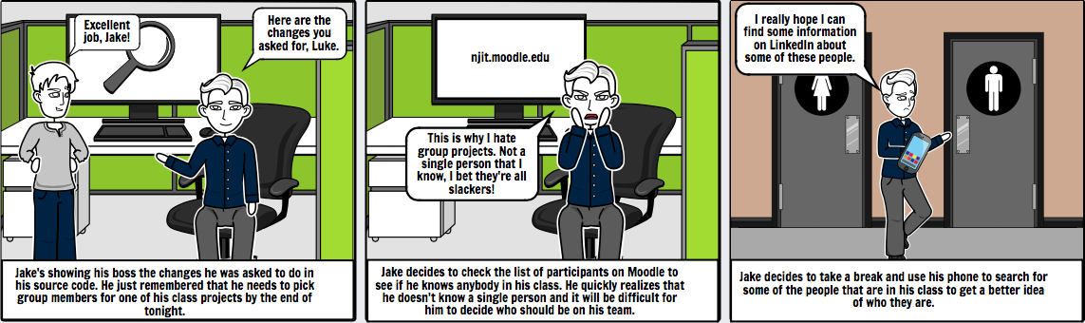

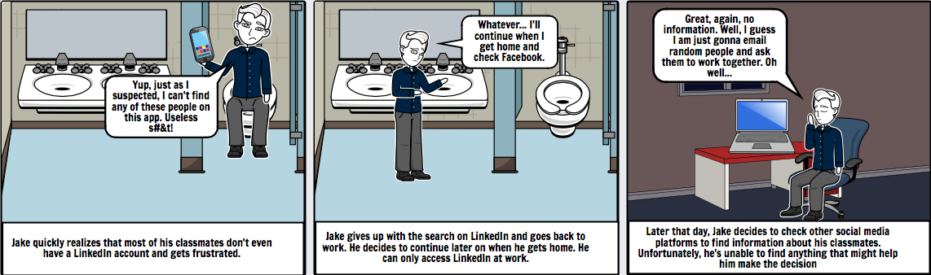

## 5.2. Problem Scenario – Jennifer Edwards

****Jennifer is an owner of a retail store at a mall in Jersey City, NJ, where she primarily sells shoes and clothing. She has been able to successfully run the store for the past 3 years, however, recently the sales have declined. It is very difficult for Jennifer to keep up with online retailers and it’s hard to compete with e-commerce giants such as Amazon or Zappos.

Jennifer has been putting a lot of effort in her retail store to make sure it grows steadily so that she can expand her business to more locations. She dreams of opening up a store in the center of New York City, however, with how things are going at the moment, she will not be able to achieve this goal.

Jennifer has tried to create social media accounts on Facebook, Twitter, and Instagram to promote her business, however, with the small number of followers, she quickly realized that it’s not so effective.

Since Jennifer’s store primarily targets high school and college students, she wants to be able to find an application that will target either of these two group of students. She does believe, however, that college students will be more likely to come to her store and buy clothes or shoes as these are usually the people that are working and supporting themselves.

Social media is very big nowadays, but it’s really hard to gain a lot of followers unless you constantly post interesting content so that followers can think it’s worth sharing with others. Jennifer is the only person responsible for running her social media accounts, but she does not have experience in this field. She does not how to effectively use social media to target potential customers, and she would be willing to explore other means of online advertising, preferably something that targets college students and has a greater exposure to more potential customers.

### 5.2.1. STORYBOARD – Jennifer Edwards

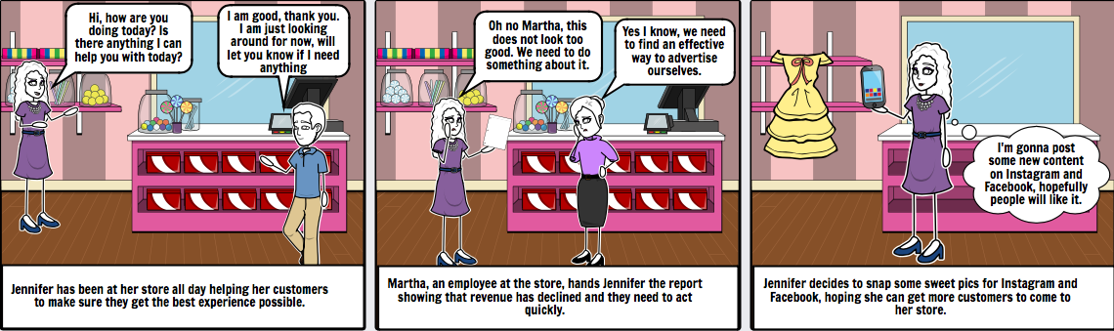

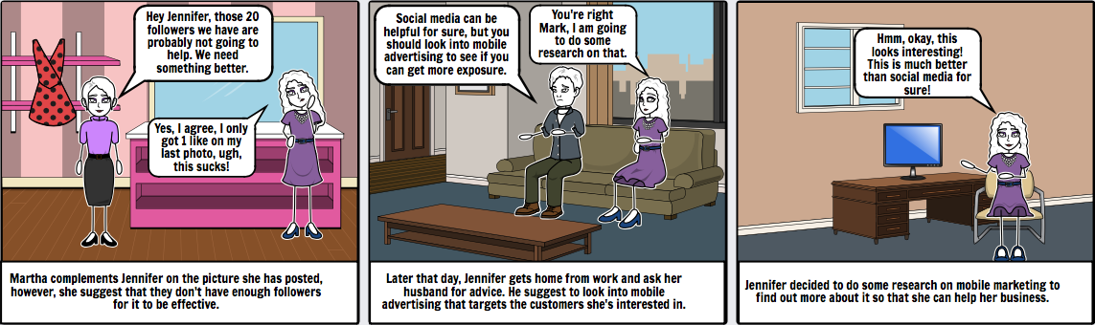

## 5.3. Problem Scenario – Trevor Crawford

****Trevor is currently an employee of the marketing department at Best Buy in Richfield, Minnesota. His primary job is to focus on improving sales of products and services. The constant threat of e-commerce sites is driving the sales down so Trevor and his college are constantly at work trying to improve Best Buy’s marketing strategy.

Outside of work, he typically spends 1-2 hours a day researching about online marketing and tries to explore different ways that he can target more customers and bring more revenue to his company. Best Buy and its marketing strategies have used online advertising to try to expose themselves to a greater number of customers, however, they still find hard to compete with online retailers.

Trevor is aware of the advancements in mobile application development and believes that mobile advertisement is the next big thing when it comes to online advertising, so he started exploring different ways of how he can incorporate mobile applications in his marketing strategy.

Also, there is currently no way to provide something more than just advertisements to users of Snapchat or Instagram. Jake and his team are open to an idea where users are shown advertisements in form of coupons that they can redeem at a local Best Buy store or their website. He knows that showing advertisements will not be affective because this is something they have tried and it’s still to compete with giant online retailers.

### 5.3.1. STORYBOARD – Trevor Crawford

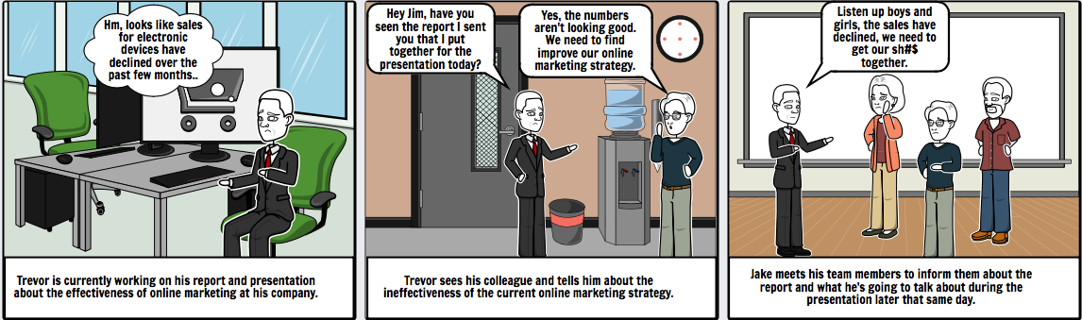

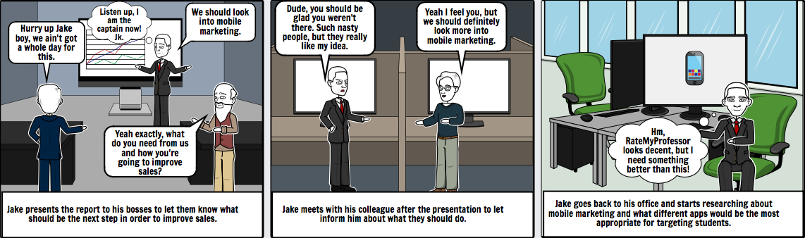

## 5.4. Problem Scenario – Bob Casey

****Bob is an assistant professor at Rutgers University in New Brunswick, New Jersey. Most of his time is spent on research related to big data where he focuses on human behavior and interactions. He enjoys doing research and teaching graduate courses in the meantime.

Many of his previous students think that Bob’s way of teaching is very engaging and they learn a lot from his lectures. Since Bob has only been teaching graduate courses for less than 2 years, he deeply cares about the feedback he gets from his students.

Even though course evaluations are available to Bob, he does not think it’s fair that this information is hidden from his potential students. Bob is aware that he is free to post this information on his website, however, he doesn’t think that it reaches the number of people that he wishes it did.

Bob often checks his profile page on RateMyProfessor to see what kind of feedback he gets. Primarily it’s because to make sure that the feedback others see about him will not affect the enrollment in a negative way. Unfortunately, RateMyProfessor does not provide any relevant information that Bob can use, and he is often left with little to no information on how he can improve his courses. He wishes that RateMyProfessor would provide more relevant information about the course and his way of teaching, rather than short comments, often related to course work.

### 5.4.1. STORYBOARD – Bob Casey

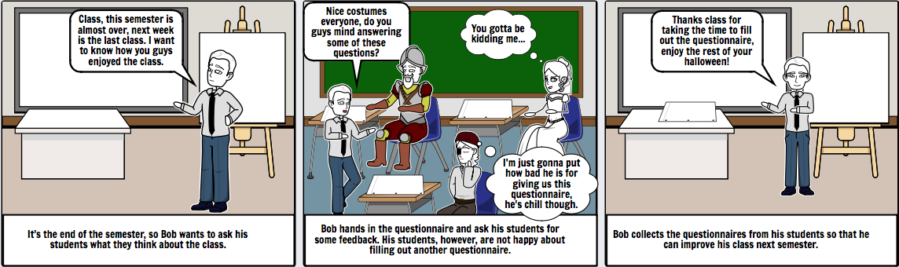

## 5.5. Problem Scenario – Blake Reed

Blake is currently a first-year graduate student at New York University. He received his bachelor of science degree in Information Systems from New York University and he decided to continue his education at the same exact institution.

Due to increase of cybercrime over the recent years, Blake has decided to learn more about cyber security so that he can help others protect their personal data. His goal is to work as a cyber security analyst in New York City and continue improving his technical skills.

So far, Blake enjoys the experience of being a graduate student at NYU. He is a part-time student as he works full-time, but still enjoys staying busy, learning new things, and meeting new people both at work and in school.

Jake wants to get information about classes and professors he’s planning on taking. He is fully aware of course evaluations being done at the end of semester for each class at NYU, however, this information is not fully accessible to students, only the school itself and its professors are able to see it. Jake is fully aware of websites such as RateMyProfessor, but they don’t provide enough information about the class or professor of his interest.

It’s hard for Jake to find reliable information about courses and professors. While at NYU, he has met many people and became friends with some of them. Whenever he needs to register for next semester, he relies on his friends from school whenever he wants to find out about a particular course or professor. Unfortunately, he does not always get what he’s looking for, and often his friends don’t have any information about the course or professor of his interest.

### 5.5.1. STORYBOARD – Blake Reed

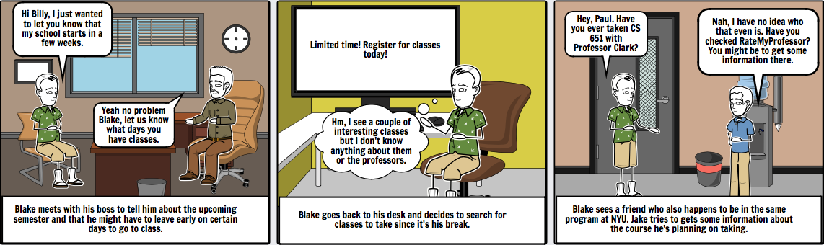

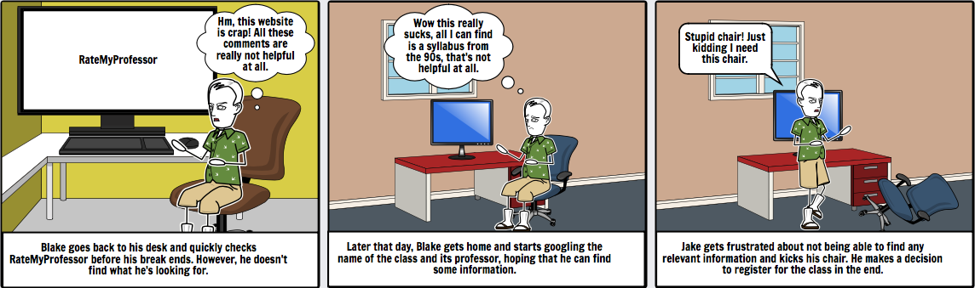

## 5.6. Problem Scenario – Jack Bauer

Author: Kumaran

****Jack is a -year graduate student at New Jersey Institute of Technology majoring in Computer Science. He is looking for software developer. Being a graduate student at NJIT, Jack is a busy person but strives to stay on top of his work. Although Jake likes going to school in general, he prefers for his teachers to assign individual assignments, rather than group projects.

Jack is a student representative and involved in raising students concerns and he is popular in his batch for this. He always wants the students to know which is best and which cn help them grow in career.

He has chosen to take “Software Design and production Methodologies” course in Master’s Computer Science course. This course needs an Android Group project to be delivered at the end of the Semester. He has taken some of the tough subjects which includes lots of projects and presentations. He wants to help his juniors to let them know which courses are better and help them in their career. He checks internet for any app or site that can help putting reviews.

He checks RATEMYPROFESSORS.COM and did not find it useful as lots of criteria were generic and not too useful. He found lots of fake reviews. He also did not find anything that can rate his fellow group members. He also didnt like the criteria that he was allowed to review about his professors and considers that this will be of very little use and would not help his friends gain from his reviews rather create lots of confusions.

### 5.6.1. STORYBOARD – Jack Bauer

Author: Kumaran

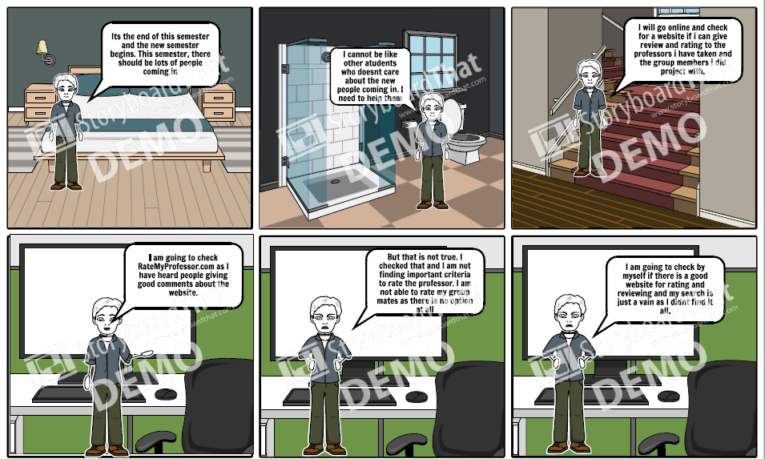

# 6. Activity Scenarios

## 6.1. Activity Scenario – Jake Simpson – Find Reliable Group Members – Best Case Scenario

****Jake has very much enjoyed the winter break and having some time off from school. Jake is aware that the Spring semester is approaching very quickly as he has been getting emails from his professors with syllabuses and other information related to the courses he’s planning on taking.

Having a brief look at some of the information shared by his professors, he noticed that nearly all of his courses require some sort of group assignments. Jake hates group assignments as he’s almost never able to find reliable group members and typically doesn’t know anyone in his classes.

Jake decides to use this new app that allows college students to rate classmates based on group performance so that others can make more informed decisions when determining who should they work with on the next group project. Jake’s primarily looking for people that finish their tasks on time and do a good job. Although he doesn’t look for any specific field of interest that a person may have, he would prefer working with someone that likes programming or is a software developer. Jake is a software developer himself, so he feels like he would be more connected with other fellow software developers.

Fortunately for Jake, his school provides a list of participants for every class he takes. Jake’s initial reaction to the information he finds about some of his classmates on the app is pretty positive. He’s able to get some general information about the performance of his classmates when it comes to group projects. He does pay a close attention to people that produce quality work and are on time with their tasks.

Since the group project allows a maximum of 4 people, he identifies 3 people that he would be interested in forming a group with. All of those classmates had at least 8 or more decent reviews and some of them were pretty recent. They all had good ratings when it came to quality of work produced and being on schedule. Although these reviews looked to be anonymous, they were pretty consistent, which has made Jake believe this information is most likely honest and it’s something that it wouldn’t hurt to trust. He likes the fact that the reviews are split into different categories, such as whether the person attends group meetings regularly, contributes to the group, or completes his/her tasks on time. Jake’s able to quickly identify the attributes he’s looking for, making his decision making more efficient.

Jake feels confident about the information he was able to gather after using the app and decides to shoot an email to all those classmates that he would like to form a group with. He quickly gets a response saying that they are willing to work with Jake on the group project.

### 6.1.1. Activity Scenario – Jake Simpson – Storyboard

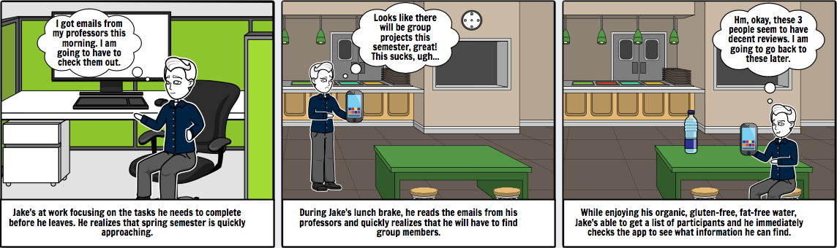

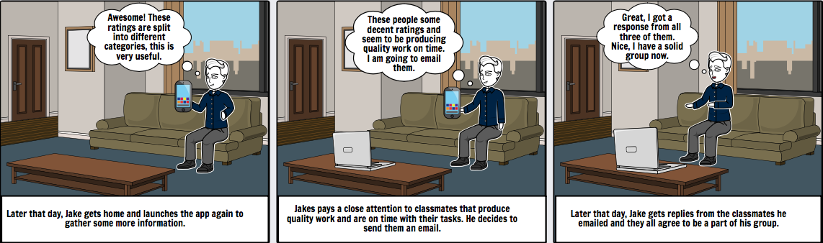

## 6.2. Activity Scenario – Jake Simpson – Find Reliable Group Members – Worst Case Scenario

****Jake has very much enjoyed the winter break and having some time off from school. Having a brief look at some of the information shared by his professors, he noticed that nearly all of his courses require some sort of group assignments. Jake hates group assignments as he’s almost never able to find reliable group members and typically doesn’t know anyone in his classes.

Jake decides to use this new app that allows college students to rate classmates based on group performance so that others can make more informed decisions when determining who should they work with on the next group project. Jake’s primarily looking for people that finish their tasks on time and do a good job. Although he doesn’t look for any specific field of interest that a person may have, he would prefer working with someone that likes programming or is a software developer. Jake is a software developer himself, so he feels like he would be more connected with other fellow software developers.

Fortunately for Jake, his school provides a list of participation for every class he takes. Jake’s initial reaction to the information he finds about some of his classmates on the app is okay. He’s been able to get some general information about the performance of his classmates when it comes to group projects, however, some of the information wasn’t as detailed as he would like it to be. Jake’s primary looking for students that can produce quality work on time. However, he notices some of the people he was able to find on the app aren’t rated in this category. The app allows reviewers to provide information based on different criteria, but it looks like the characteristics valued by Jake have been omitted by most reviewers.

Jake is having mixed feelings about the information that he gets, however, he notices that some of the categories that reviewers get to provide their feedback on are mandatory and cannot be omitted. Two of them rate students based on whether they demonstrate a cooperative and supportive attitude and whether they contribute meaningfully to group discussions. Even though these characteristics are of lesser importance, he could still use that information to help him make a more informed decision.

Jake’s options have expanded due to the missing information he was interested in, however, he is still able to get a good idea of who should be in his group. He was able to find some decent reviews on a few of his classmates, which also suggested that these people are fairly good at participating in group discussions and showing a cooperative and supportive attitude. Jake decides to contact those classmates and the next day he gets a response saying that they are willing to work with Jake on the group project.

# 7. Information Scenario

## 7.1. Jake Simpson – Find Reliable Group Members

Jake is aware that the Spring semester is approaching very quickly as he has been getting emails from his professors with syllabuses and other information related to the course he’s taking. He noticed that nearly all his courses require some sort of group assignments. Jake hates group assignments as he’s never able to find reliable group members. Jake decides to use this new app that allows college students to rate classmates based on group performance.

Jake’s interested in people that can finish their tasks on time and produce quality work. Although he doesn’t look for any specific field of interest that a person may have, he would prefer working with someone that likes programming or is a software developer. Jake’s a software developer himself, so he feels that he would be more connected with other fellow software developers.

Fortunately for Jake, his school allows him to get a list of participants for every class he takes. Jake’s able to quickly identify who’s in his classes and starts searching some names on the app. Jake remembers that upon registration, he filled out a form with his personal information, which included the list of school he attended. Jake likes the fact that the `home` screen shows him a list of students and professors from the schools he has chosen upon registration. He’s able to quickly identify the amount of ratings and the overall score for each person. All this information is available to Jake because of other students’ feedback.

Jake starts to type in some names in the search bar and is quickly able to find the people he’s looking for. At a first glance, they appear to have good overall ratings so he decides to look at their profiles to get more information about them. Jake’s presented with general information about his classmates along with their majors and schools that they have attended. The reviewers’ have also provided information related to group performance in form of ratings related to overall contribution to the project, cooperation, and others.

Jake sees that the people he identified have decent overall ratings, however the ratings in the “Completes Tasks on Time” and “Quality of Completed Work” categories are missing. The ones that are not missing rate students based on whether they demonstrate a cooperative and supportive attitude and if they contribute meaningfully to group discussions. Even though these characteristics are of lesser importance, Jake’s still able to use that information.

Jake has picked potential group members that had good overall ratings and high ratings when it came to demonstrating a cooperative and supportive attitude and contributing to group discussions. He gets their emails from his school’s website and decides to contact them. The next day, Jake gets a response from them saying that they are willing to work with Jake.

# 8. Key Path Scenario

## 8.1. Persona Involved: Jake Simpson || Finding Reliable Group members

**Searching for Students**

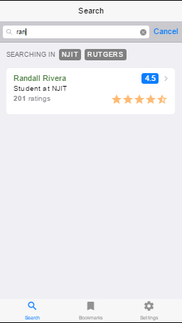

**Viewing Ratings for Student: Overview / Comments**

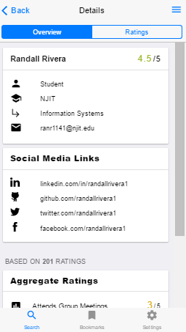 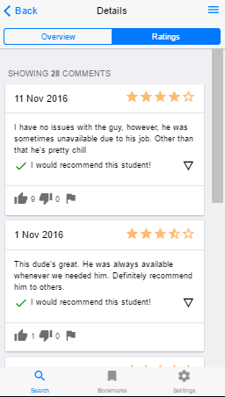

## 8.2. Persona Involved: Blake Reed || Finding Information About Professor and Students

**Searching Professors**

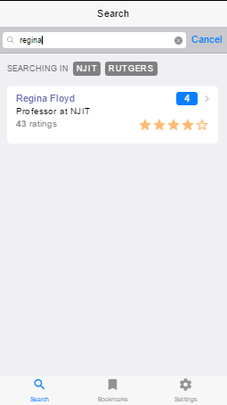

**Reviewing Rating for Professor: overview/ comments**

